CSIT 491 — Lab 3
Firewall Implementation & Access Control

Anthony Castellanos, Imran Ahmed, Murtaza Syed, Nicolas Hoyos, Shaied Uddin
Course: CSIT 491
Instructor: Ramy Othman
Date: April 12, 2026

1. Introduction
The purpose of this lab was to configure a firewall using an Extended Named Access Control List (ACL) on a Cisco 2811 router in Cisco Packet Tracer. The ACL was designed to permit specific types of traffic while blocking others, simulating a basic firewall policy between a PC and a server.

The lab involved configuring router interfaces, defining ACL rules, applying the ACL to the correct interface and direction, and verifying enforcement through live traffic testing and Wireshark captures.

This lab demonstrates understanding of:
- Extended Named ACL configuration on Cisco IOS
- Interface direction and ACL placement
- Permitted and denied traffic testing
- ACL hit counter verification using show access-list
- Wireshark traffic analysis

2. Network Topology
The network consisted of 1 Router (Cisco 2811 with FastEthernet interfaces), 1 PC (PC0), and 1 Server (Server0). There was no switch — PC0 and Server0 were connected directly to the router on separate interfaces.

[ Screenshot: Packet Tracer Network Topology — PC0, Router0, Server0 ]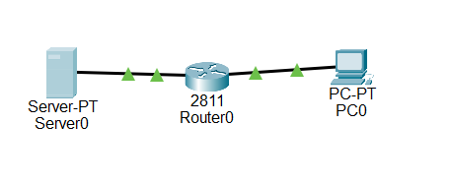

IP Address Assignments

Device | Interface | IP Address | Subnet Mask
Router0 | Fa0/0 | 10.0.0.1 | 255.255.255.0
Router0 | Fa0/1 | 192.168.1.1 | 255.255.255.0
Server0 | NIC | 10.0.0.10 | 255.255.255.0
PC0 | NIC | 192.168.1.10 | 255.255.255.0

3. Network Setup
Before configuring the ACL, both Server0 and PC0 were assigned static IP addresses through the Packet Tracer device configuration panels.

Server0 Configuration
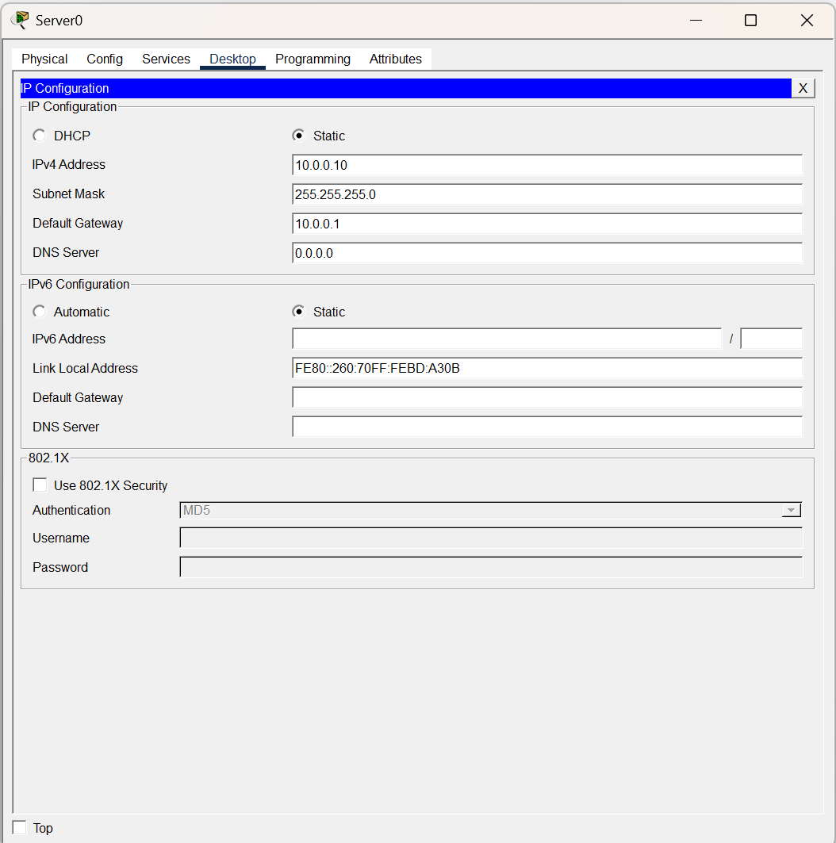

PC0 Configuration
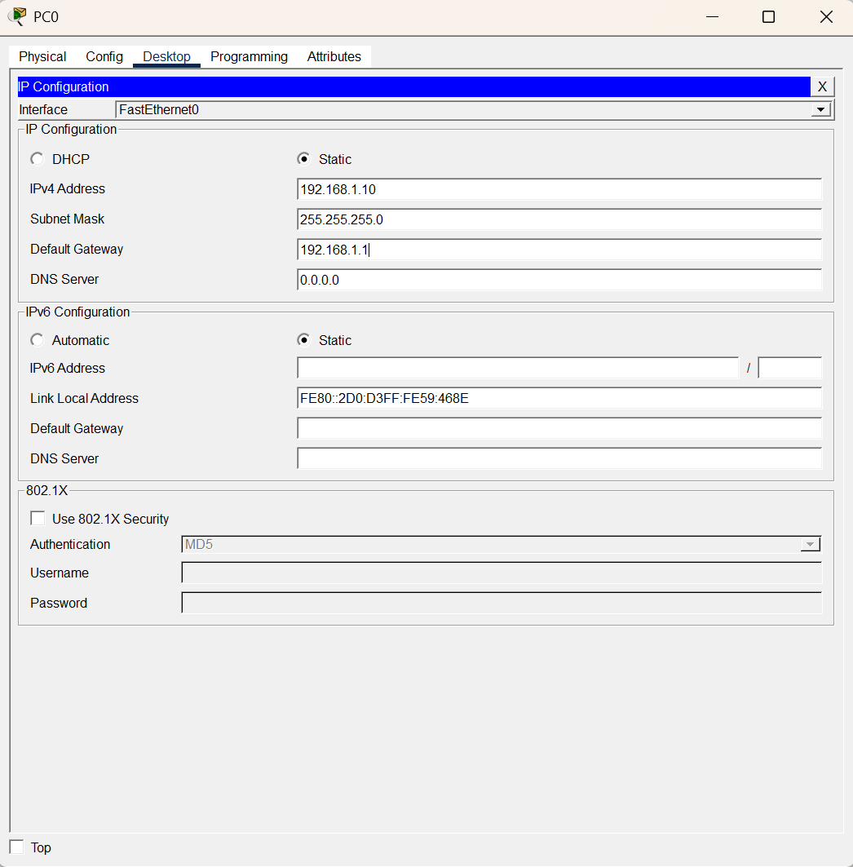

4. Firewall Configuration
The router interfaces were configured with IP addresses and brought up using the following commands:

Router>enable
Router#configure terminal
Router(config)#interface FastEthernet0/0
Router(config-if)#ip address 10.0.0.1 255.255.255.0
Router(config-if)#no shutdown
Router(config-if)#exit
Router(config)#interface FastEthernet0/1
Router(config-if)#ip address 192.168.1.1 255.255.255.0
Router(config-if)#no shutdown
Router(config-if)#exit

After configuration, both interfaces were verified as up/up using:

Router(config)#do show ip interface brief

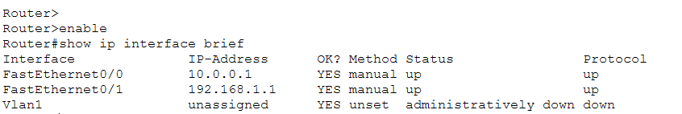

5. ACL Configuration
An Extended Named ACL called FIREWALL_POLICY was created to control traffic from PC0 to Server0. The policy permits HTTP and HTTPS traffic, denies SSH and Telnet, and allows all other IP traffic through a final catchall rule.

Router(config)#ip access-list extended FIREWALL_POLICY
Router(config-ext-nacl)#permit tcp any any eq 80
Router(config-ext-nacl)#permit tcp any any eq 443
Router(config-ext-nacl)#deny tcp any any eq 22
Router(config-ext-nacl)#deny tcp any any eq 23
Router(config-ext-nacl)#permit ip any any
Router(config-ext-nacl)#exit
Router(config)#interface FastEthernet0/1
Router(config-if)#ip access-group FIREWALL_POLICY in
Router(config-if)#exit

ACL Rule Summary

Rule # | Description | Port | Action
10 | permit tcp any any eq www | 80 | Permit
20 | permit tcp any any eq 443 | 443 | Permit
30 | deny tcp any any eq 22 | 22 | Deny
40 | deny tcp any any eq telnet | 23 | Deny
50 | permit ip any any | All | Permit

The ACL was applied inbound on FastEthernet0/1 (the PC-side interface) so that traffic from PC0 is filtered as it enters the router, before being forwarded to Server0.

ACL verification was confirmed using show access-list:

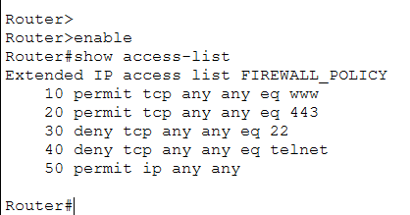

6. Traffic Testing

Allowed Traffic — HTTP (Port 80)
From PC0's web browser, an HTTP request was sent to http://10.0.0.10. The page loaded successfully, confirming that rule 10 (permit tcp any any eq 80) was correctly allowing HTTP traffic.

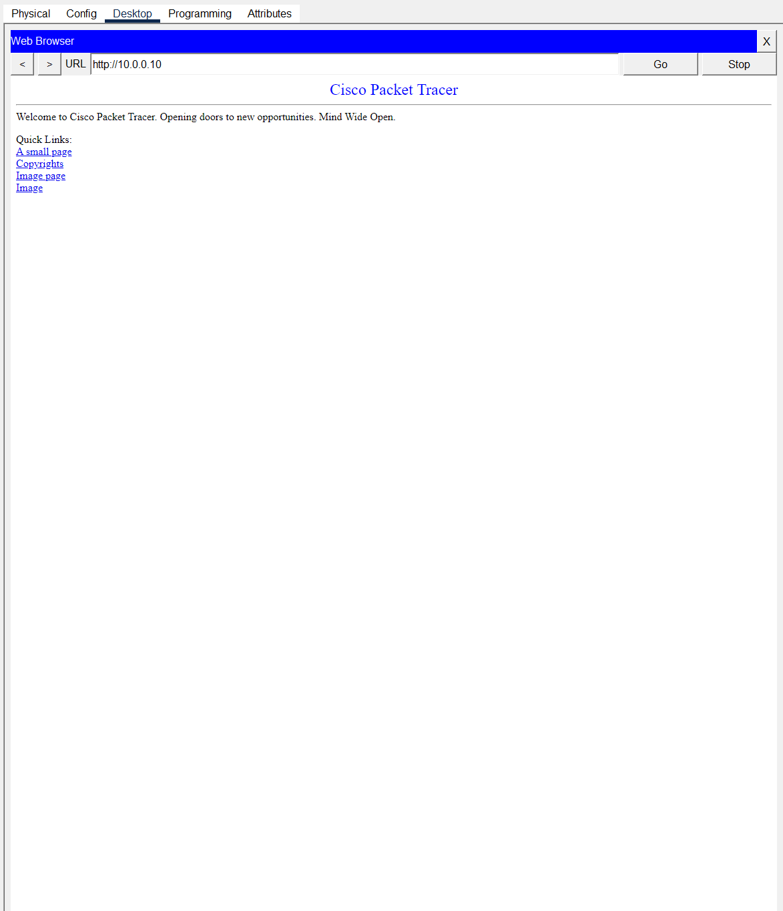

Allowed Traffic — HTTPS (Port 443)
HTTPS traffic on port 443 was also confirmed as permitted by the ACL through Wireshark captures showing a complete TLS handshake and application data exchange.

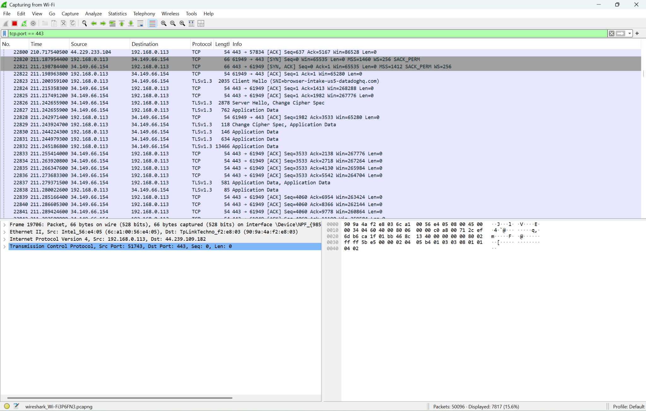

Blocked Traffic — Telnet (Port 23)
A Telnet connection attempt to Server0 (10.0.0.10) timed out, confirming that rule 40 (deny tcp any any eq telnet) was blocking the connection. The show access-list output showed incrementing hit counters on the deny rule after each attempt.

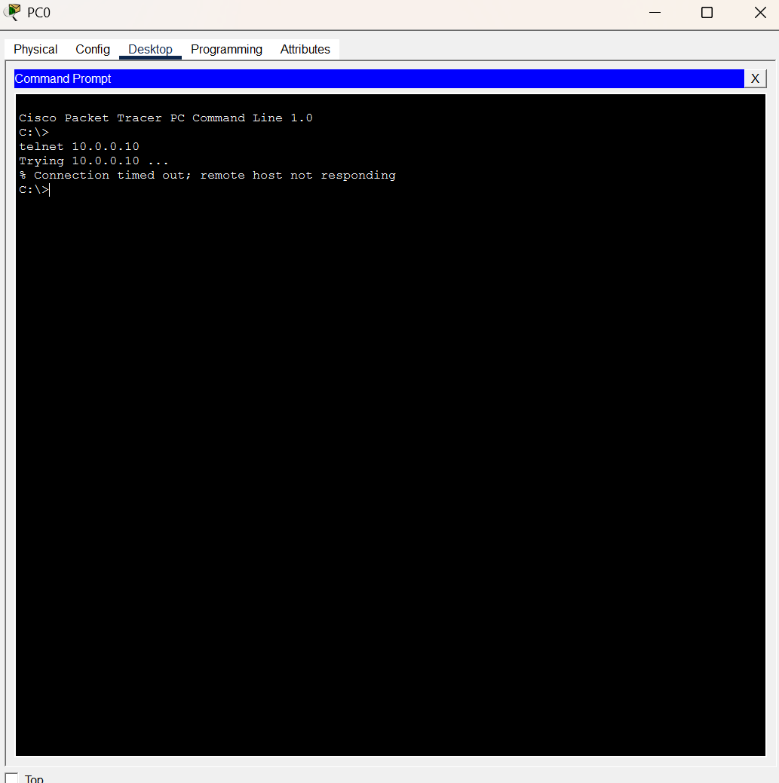



7. Wireshark Analysis

Blocked Telnet Traffic (Port 23)
Wireshark was used to capture traffic filtered by tcp.port == 23. The capture showed SYN packets being sent from the source immediately followed by RST/ACK reset packets from the destination, confirming that the connection was refused and no successful Telnet session was established on port 23.

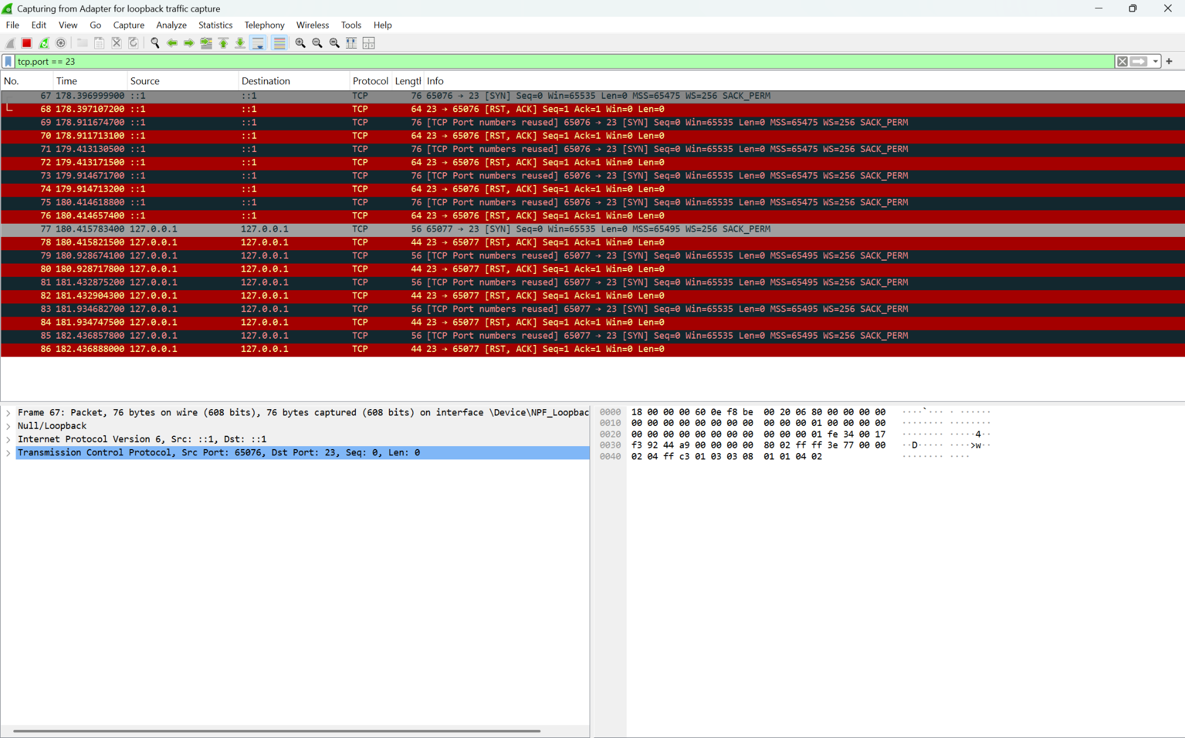

Successful HTTPS Traffic (Port 443)
A separate Wireshark capture filtered by tcp.port == 443 showed a complete TLS handshake including SYN, SYN-ACK, and application data packets, confirming that HTTPS traffic was permitted through the firewall without any resets.



8. Observations
- The ACL was first applied on FastEthernet0/0 inbound (the server-side interface), which blocked Server0 from being reached by PC0 entirely. This happened because Fa0/0 inbound filters traffic coming from the server, not from PC0. After recognizing the issue, the ACL was moved to FastEthernet0/1 inbound, which correctly filtered PC0’s outgoing requests before they crossed the router.
- ACL hit counters in show access-list initially showed zero after applying the ACL. We hadn’t generated any traffic yet at that point. Once HTTP and Telnet tests were run, the counters updated and confirmed each rule was being matched correctly.
- The order of rules in the ACL matters significantly. The deny rules for SSH (port 22) and Telnet (port 23) had to be placed before the final permit ip any any catchall. If the catchall appeared first, all traffic would be permitted before reaching the deny rules, making the firewall ineffective.
- Wireshark confirmed the firewall behavior at the packet level. Blocked Telnet traffic showed the SYN + RST/ACK pattern, indicating the connection was rejected. Permitted HTTPS traffic showed a full TLS handshake, confirming successful communication on port 443.
- The Wireshark captures were performed on a real Windows host (localhost) rather than from inside Packet Tracer, since Packet Tracer does not support native Wireshark integration. Filtering by tcp.port == 23 and tcp.port == 443 made it straightforward to isolate and interpret the relevant traffic.

9. Conclusion
This lab successfully demonstrated the configuration and enforcement of a firewall policy using an Extended Named ACL on a Cisco 2811 router. By defining specific permit and deny rules and applying the ACL inbound on the correct interface, traffic filtering between PC0 and Server0 was achieved as intended.

HTTP and HTTPS traffic were permitted, Telnet was blocked, and ACL hit counters along with Wireshark captures confirmed that the rules were functioning correctly. The objectives of Lab 3 were fully met.

